Wiring and Connector Standards

GT Off-Road Racing | Data Acquisition

Ryan Chen

06/14/2021

Table of Contents

1.0 Overview 3

1.1 Introduction 3

2.0 Wiring Standards 4

2.1 Connector genders between electrical components 4

2.2 Securing wires 4

3.0 Connector Pinout Standards 5

3.1 Introduction 5

3.2 XT30 5

Power 5

3.3 Molex Micro-Fit 3.0 6

3.3.1 2-pin 6

Other 6

3.3.2 3-pin 6

Signal 6

Other 6

Serial or UART (for self-powered systems) 6

3.3.3 4-pin 7

I2C 7

Serial/UART (for downstream devices that require a power source) 7

Strain Gauge PCB Input 7

Strain Gauge PCB Output Signal 7

Aux DAQ Serial (RX/TX) 7

Dashboard Serial (RX/TX) 7

Other 7

3.3.4 6-pin 8

SPI 8

Other 8

3.4 Weather-Pack 9

3.4.1 2-pin 9

Li-Po Batteries 9

3.5 Molex Squba 9

3.5.1 3-pin 9

I2C 9

3.5.2 4-pin 9

I2C 10

3.6 Metri-Pack 10

3.6.1 3-pin 10

Signal 10

4.0 References 12

5.0 Revision History 13

# Overview

## Introduction

# Wiring Standards

## Connector genders between electrical components

All connectors attached to an electrical component/system (PCB, battery, sensor, etc.) from components are male.

[Add analogy about islands and bridges]

All bridging cables/wires are female.

Figure 1: High-level overview of electrical wiring

## Securing wires

Wires are secured to the car by zip ties. The zip ties typically go through mounting tabs on the car, but can also go around the chassis frame.

# Connector Pinout Standards

## Introduction

A few key rules:

* If a custom color/pin pattern is used, include the connector diagram and pinout table in the relevant project’s documentation.

## XT30

|  |  |
| --- | --- |
| Female | Male |

Figure 2: XT30 Connectors

#### Power

|  |  |  |
| --- | --- | --- |
| **Pin** | **Color** | **Description** |
| + | Red | Power |
| - | Black | Ground |

## Molex Micro-Fit 3.0

### 2-pin

|  |  |
| --- | --- |
| Female | Male |

Figure 3: Micro-Fit 2-pin connector

|  |  |  |  |  |  |  |  |  |  |  |
| --- | --- | --- | --- | --- | --- | --- | --- | --- | --- | --- |
| Other  |  |  |  | | --- | --- | --- | | **Pin** | **Color** | **Description** | | 1 | Red |  | | 2 | White | Ground | |  |

### 3-pin

|  |  |
| --- | --- |
| Female | Male |

Figure 4: Micro-Fit 3-pin connector

|  |  |  |  |  |  |  |  |  |  |  |  |  |  |  |  |  |  |  |  |  |  |  |  |  |  |
| --- | --- | --- | --- | --- | --- | --- | --- | --- | --- | --- | --- | --- | --- | --- | --- | --- | --- | --- | --- | --- | --- | --- | --- | --- | --- |
| Signal  |  |  |  | | --- | --- | --- | | **Pin** | **Color** | **Description** | | 1 | Red | Power | | 2 | White | Signal | | 3 | Black | Ground | | Other  |  |  |  | | --- | --- | --- | | **Pin** | **Color** | **Description** | | 1 | Red |  | | 2 | White |  | | 3 | Black |  | |
| Serial or UART (for self-powered systems)  |  |  |  | | --- | --- | --- | | **Pin** | **Color** | **Description** | | 1 | Red | TX or RX | | 2 | White | TX or RX | | 3 | Black | Ground | |  |

### 4-pin

|  |  |
| --- | --- |
| Female | Male |

Figure 5: Micro-Fit 4-pin connector

|  |  |  |  |  |  |  |  |  |  |  |  |  |  |  |  |  |  |  |  |  |  |  |  |  |  |  |  |  |  |  |  |
| --- | --- | --- | --- | --- | --- | --- | --- | --- | --- | --- | --- | --- | --- | --- | --- | --- | --- | --- | --- | --- | --- | --- | --- | --- | --- | --- | --- | --- | --- | --- | --- |
| I2C  |  |  |  | | --- | --- | --- | | **Pin** | **Color** | **Description** | | 1 | Red | Power | | 2 | Green | I2C Data (SDA) | | 3 | White | I2C Clock (SCL) | | 4 | Black | Ground | | Serial/UART (for downstream devices that require a power source)  |  |  |  | | --- | --- | --- | | **Pin** | **Color** | **Description** | | 1 | Red | Power | | 2 | Green | RX or TX | | 3 | White | RX or TX | | 4 | Black | Ground | |
| Strain Gauge PCB Input  |  |  |  | | --- | --- | --- | | **Pin** | **Color** | **Description** | | 1 | Red | Power | | 2 | Green | A+ | | 3 | White | A- | | 4 | Black | Ground | | Strain Gauge PCB Output Signal  |  |  |  | | --- | --- | --- | | **Pin** | **Color** | **Description** | | 1 | Red | Power | | 2 | Green | Vout | | 3 | N/A | N/A | | 4 | Black | Ground | |
| Aux DAQ Serial (RX/TX)  |  |  |  | | --- | --- | --- | | **Pin** | **Color** | **Description** | | 1 | Red |  | | 2 | N/A |  | | 3 | White |  | | 4 | Black | Ground | | Dashboard Serial (RX/TX)  |  |  |  | | --- | --- | --- | | **Pin** | **Color** | **Description** | | 1 | Red | Aux DAQ TX | | 2 | N/A |  | | 3 | White | Aux DAQ RX | | 4 | Black | Ground | |
| Other  |  |  |  | | --- | --- | --- | | **Pin** | **Color** | **Description** | | 1 | Red | Power | | 2 | Green |  | | 3 | White |  | | 4 | Black | Ground | |  |

### 6-pin

|  |  |
| --- | --- |
| Female | Male |

Figure 6: Micro-Fit 6-pin connector

|  |  |  |  |  |  |  |  |  |  |  |  |  |  |  |  |  |  |  |  |  |  |  |  |  |  |  |  |  |  |  |  |  |  |  |  |  |  |  |  |  |  |  |  |
| --- | --- | --- | --- | --- | --- | --- | --- | --- | --- | --- | --- | --- | --- | --- | --- | --- | --- | --- | --- | --- | --- | --- | --- | --- | --- | --- | --- | --- | --- | --- | --- | --- | --- | --- | --- | --- | --- | --- | --- | --- | --- | --- | --- |
| SPI  |  |  |  | | --- | --- | --- | | **Pin** | **Color** | **Description** | | 1 | Red | Power | | 2 | Green | MOSI | | 3 | Blue | MISO | | 4 | Orange | Serial clock (SCK) | | 5 | White | Chip select (CS) | | 6 | Black | Ground | | Other  |  |  |  | | --- | --- | --- | | **Pin** | **Color** | **Description** | | 1 | Red | Power | | 2 | Green |  | | 3 | Blue |  | | 4 | Orange |  | | 5 | White |  | | 6 | Black | Ground | |

## Weather-Pack

### 2-pin

|  |  |
| --- | --- |
| Female | Male |

Figure 7: Weather-Pack 2-pin connector

Li-Po Batteries

|  |  |  |
| --- | --- | --- |
| **Pin** | **Color** | **Description** |
| 1 | Black | Ground |
| 2 | Red | Power |

## Molex Squba

### 3-pin

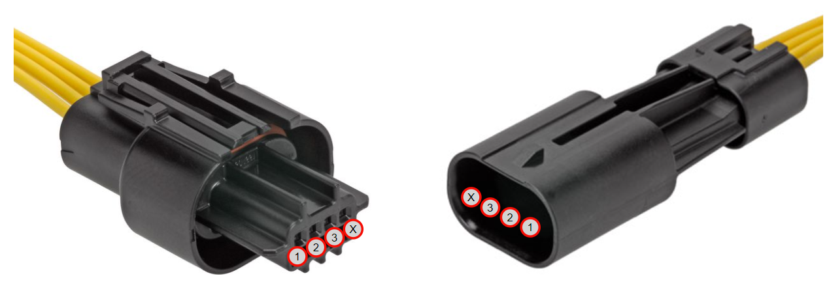

|  |  |
| --- | --- |
| Female | Male |

Figure 8: Molex Squba 4-pin connector

|  |  |  |  |  |  |  |  |  |  |  |  |  |  |  |  |  |
| --- | --- | --- | --- | --- | --- | --- | --- | --- | --- | --- | --- | --- | --- | --- | --- | --- |
| I2C  |  |  |  | | --- | --- | --- | | **Pin** | **Color** | **Description** | | 1 | Red | Power | | 2 | White | Signal | | 3 | Black | Ground | | 4 | N/A | Plugged shut (waterproof) | |  |

### 4-pin

|  |  |
| --- | --- |
| Female | Male |

Figure 9: Molex Squba 4-pin connector

|  |  |  |  |  |  |  |  |  |  |  |  |  |  |  |  |  |
| --- | --- | --- | --- | --- | --- | --- | --- | --- | --- | --- | --- | --- | --- | --- | --- | --- |
| I2C  |  |  |  | | --- | --- | --- | | **Pin** | **Color** | **Description** | | 1 | Red | Power | | 2 | Green | I2C Data (SDA) | | 3 | White | I2C Clock (SCL) | | 4 | Black | Ground | |  |

## Metri-Pack

### 3-pin

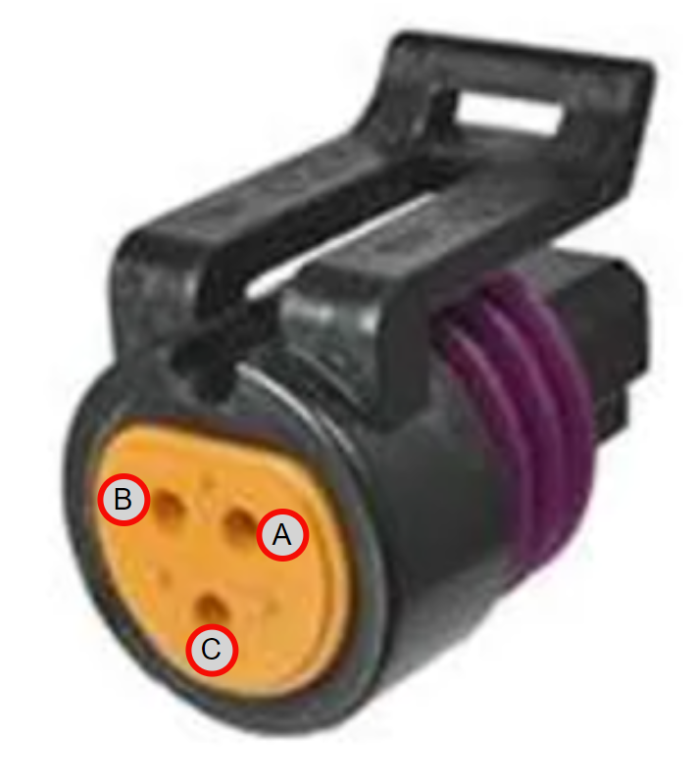

|  |
| --- |
| Female |

Figure 10: Metri-Pack 3-pin connector

|  |  |  |  |  |  |  |  |  |  |  |  |  |
| --- | --- | --- | --- | --- | --- | --- | --- | --- | --- | --- | --- | --- |
| Signal  |  |  |  | | --- | --- | --- | | **Pin** | **Color** | **Description** | | A | Red | Power | | B | Black | Ground | | C | White | Signal | |

# References

# Revision History

9/16/2021 (Ryan Chen) – Created high-level wiring standards for electrical systems/PCBs on the car. Inserted pictures of pins and empty tables of pinout diagrams for connectors.

5/15/2022 (Ryan Chen) – Added Squba and Metri-Pack information